EA2-DATA CLEANING AND TRANSFORMATION

CLEANED DATA

CREATE TABLE
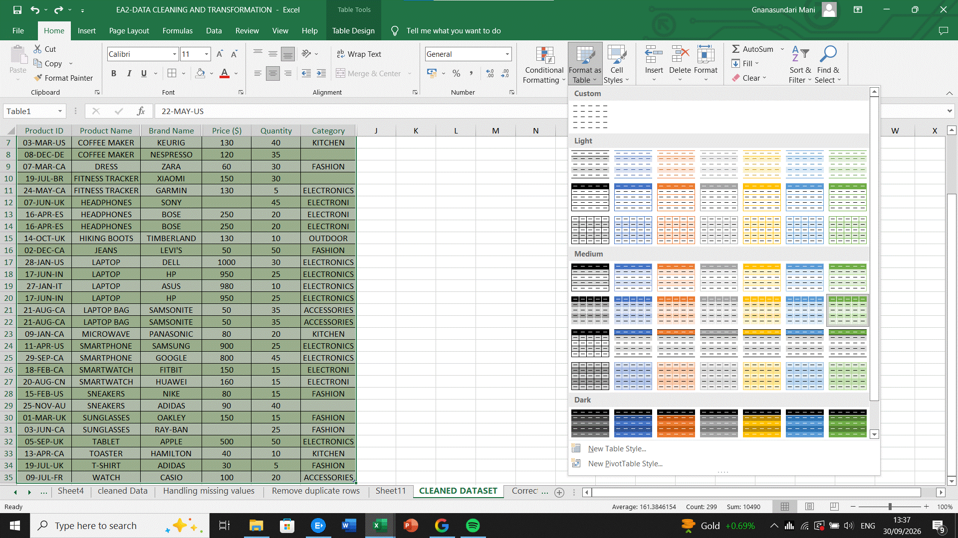
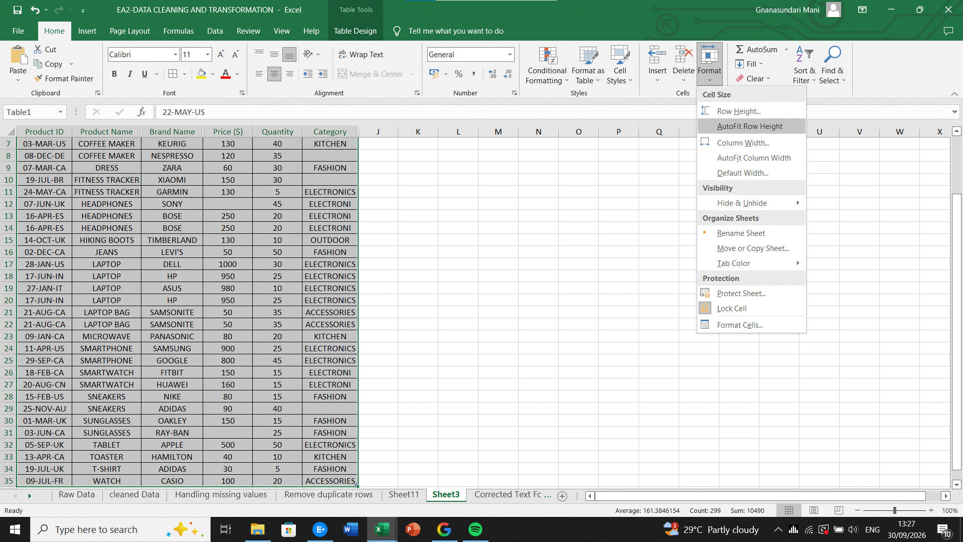
CENTER ALIGNMENT OF TEXT
TRIM() FUNCTION USING FOR REDUCE EXTRA SPACE
PROPER FUNCTION() USED FOR TEXT

HANDLING MISSING VALUES

Identify the missing values of “Price” column and “category” column.
Price column productwise average calculate and fill up in the blank Price
Category column missing value fill up with the product wise category.

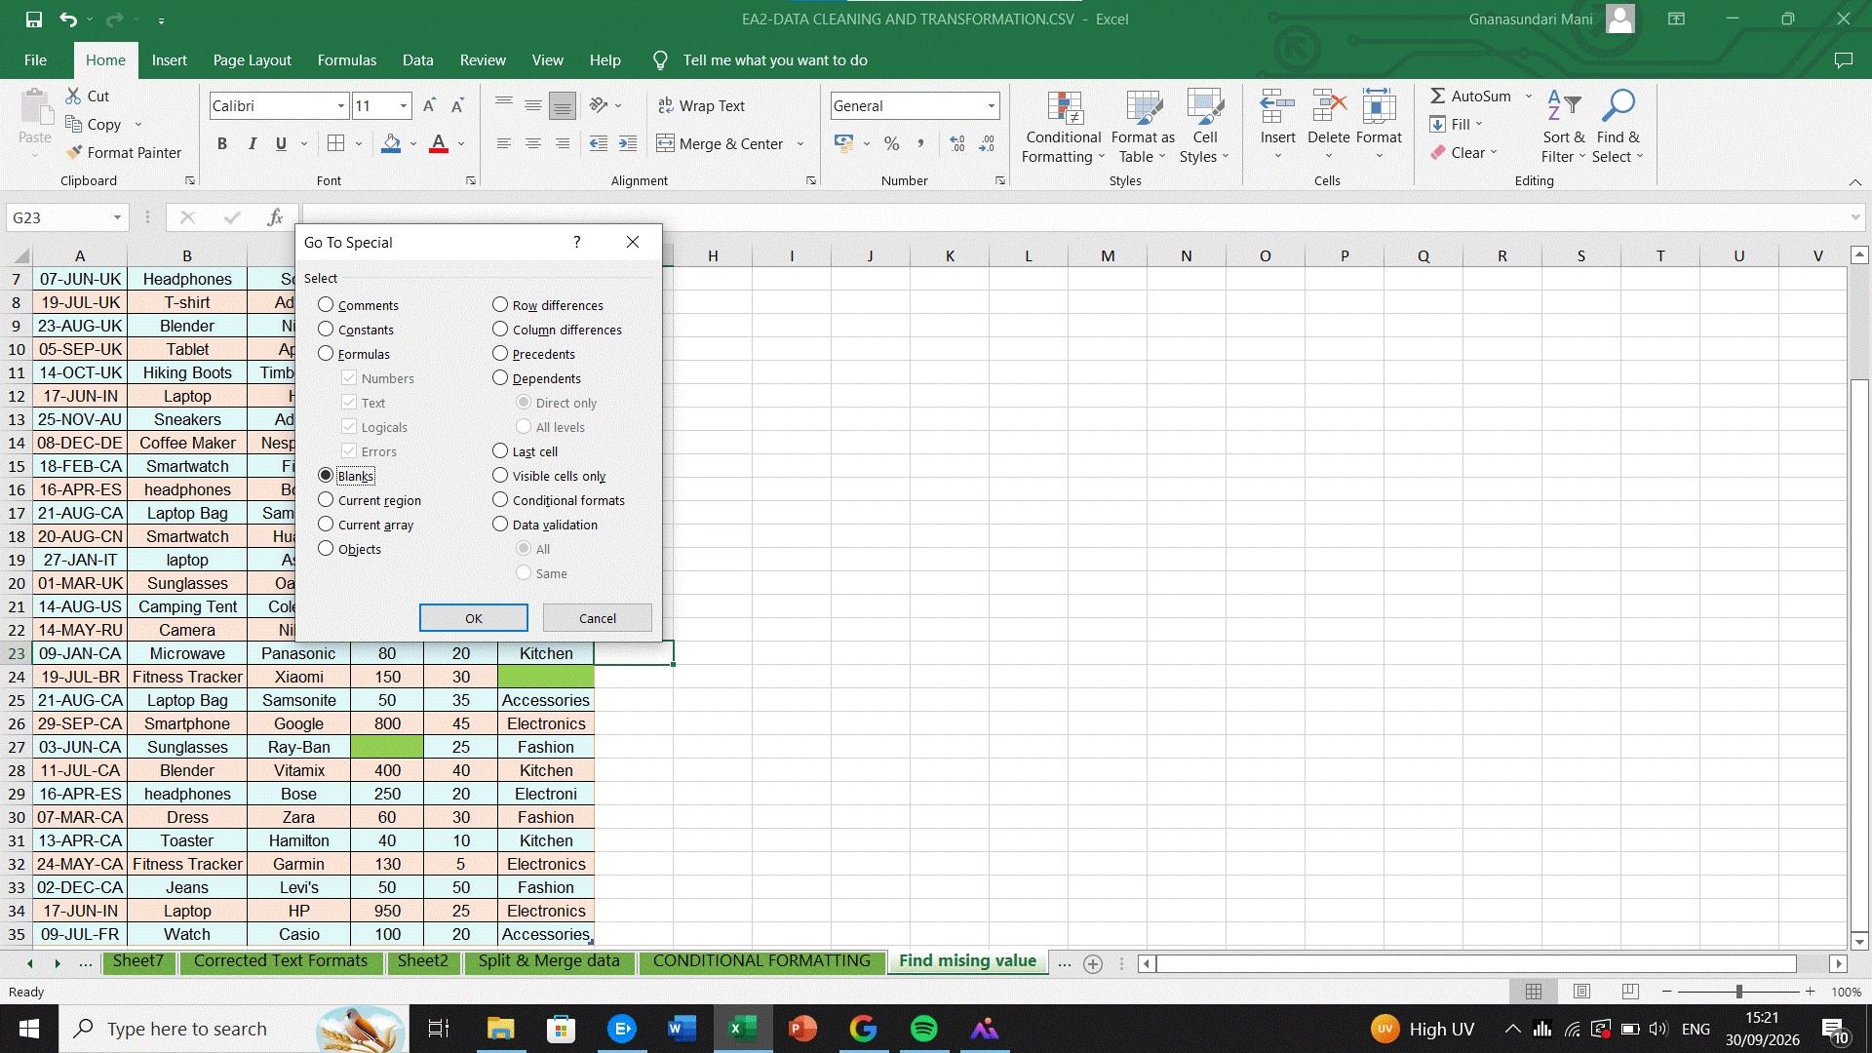
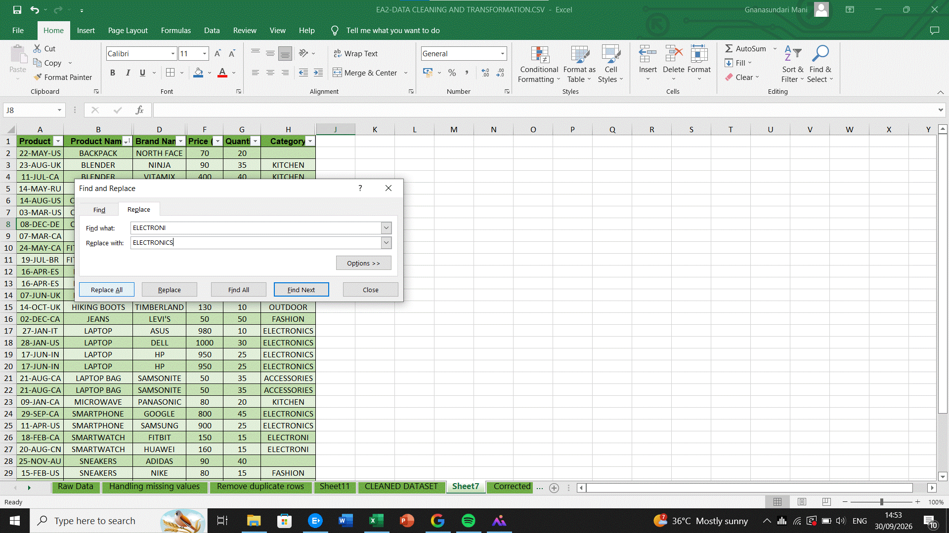

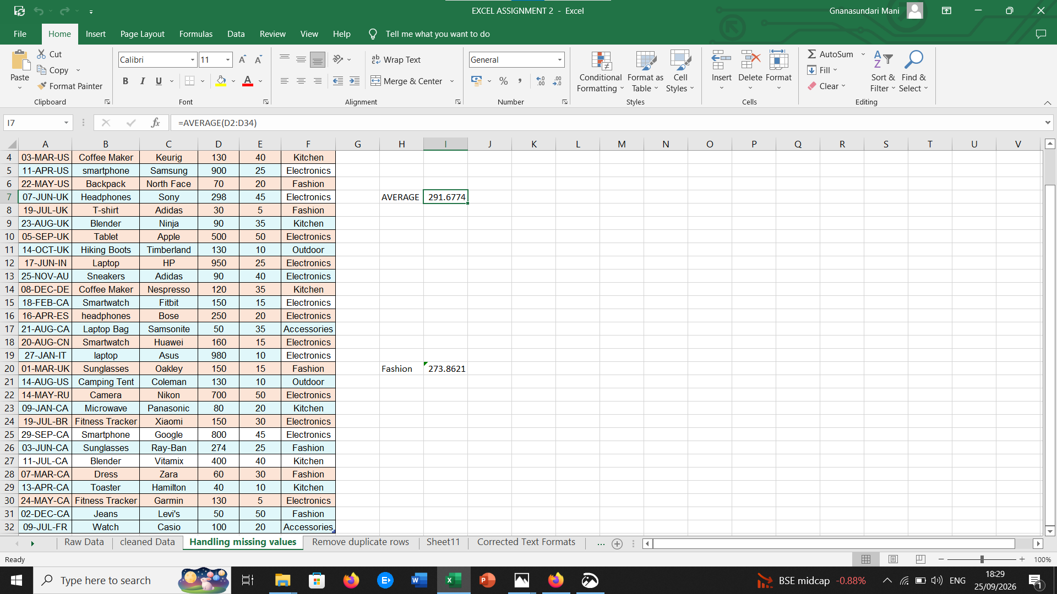

Correcting inconsistent data

REMOVING DUPLICATES

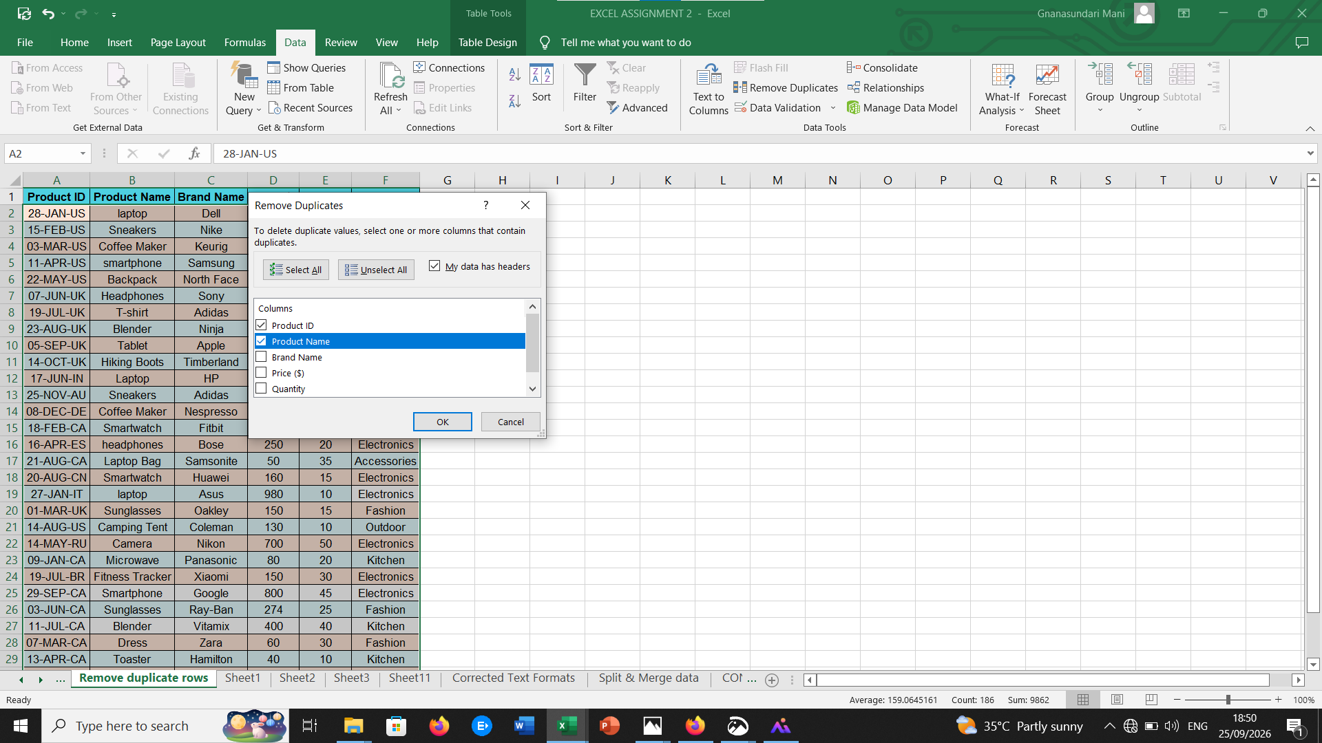

SPLIT AND MERGING TEXT COLUMNS:

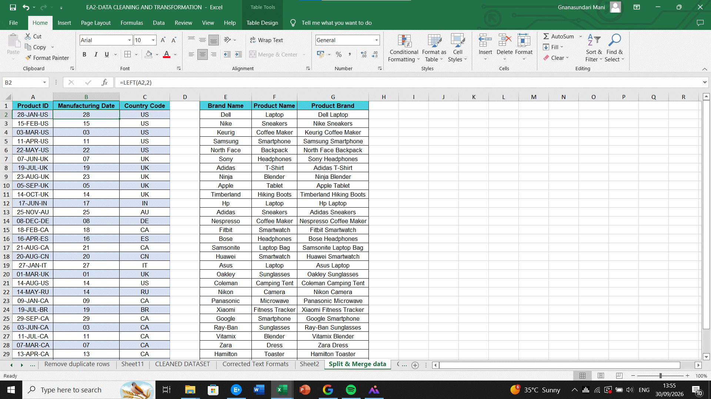

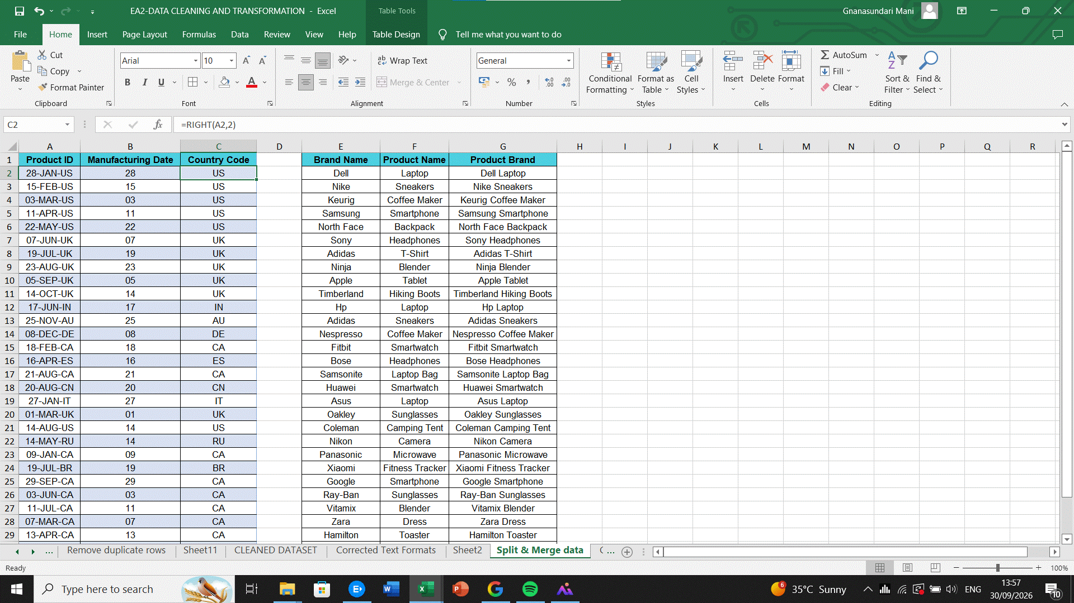
MERGE WITH CONCAT() FUNCTION

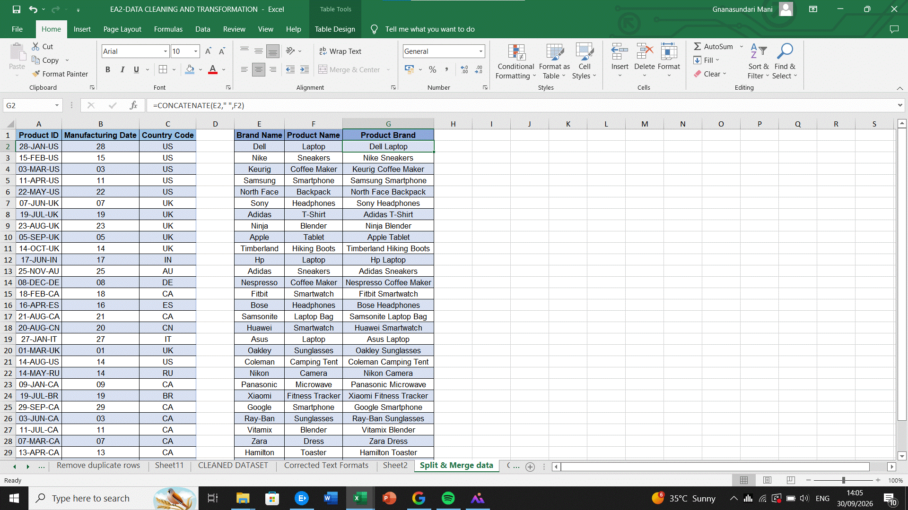

NUMBER FORMATTING:

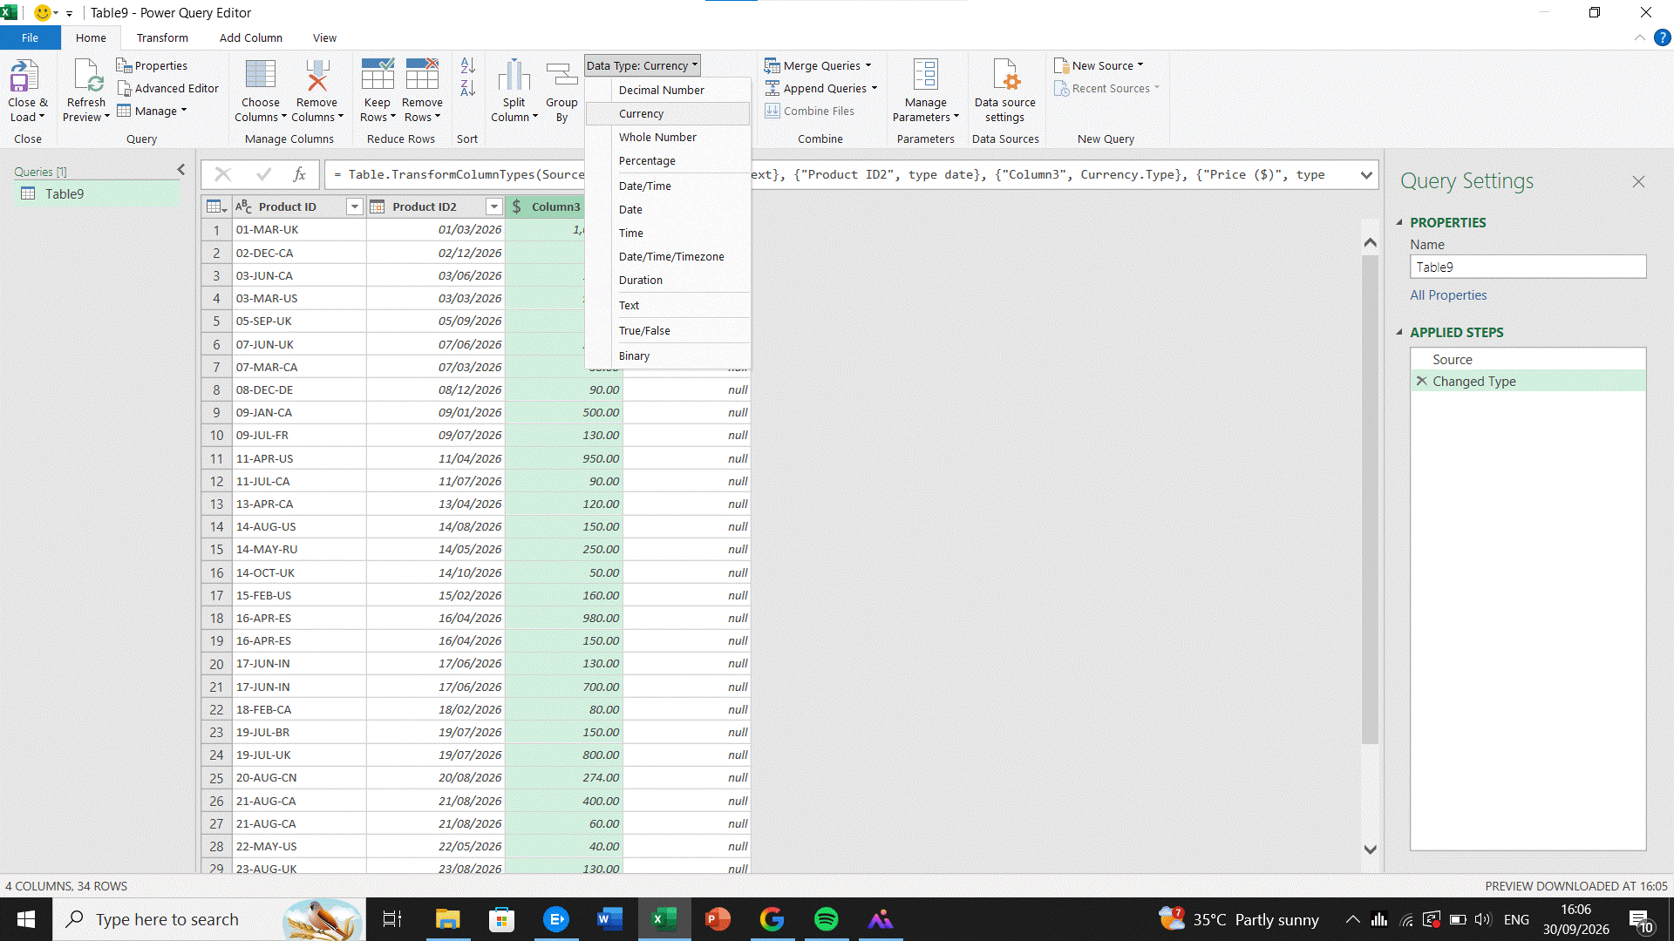

CONDITIONAL FORMATTING:

